Project Design Phase
Solution Architecture

Date | 31 January 3035
Team ID | SWTID-2026-3968
Project Name | AI FAQ Assistant
Maximum Marks | 4 Marks

Solution Architecture:
Solution architecture is a complex process – with many sub-processes – that bridges the gap between business problems and technology solutions. Its goals are to:
- Find the best tech solution to solve existing business problems.
- Describe the structure, characteristics, behavior, and other aspects of the software to project stakeholders.
- Define features, development phases, and solution requirements.
- Provide specifications according to which the solution is defined, managed, and delivered.

Example - Solution Architecture Diagram:

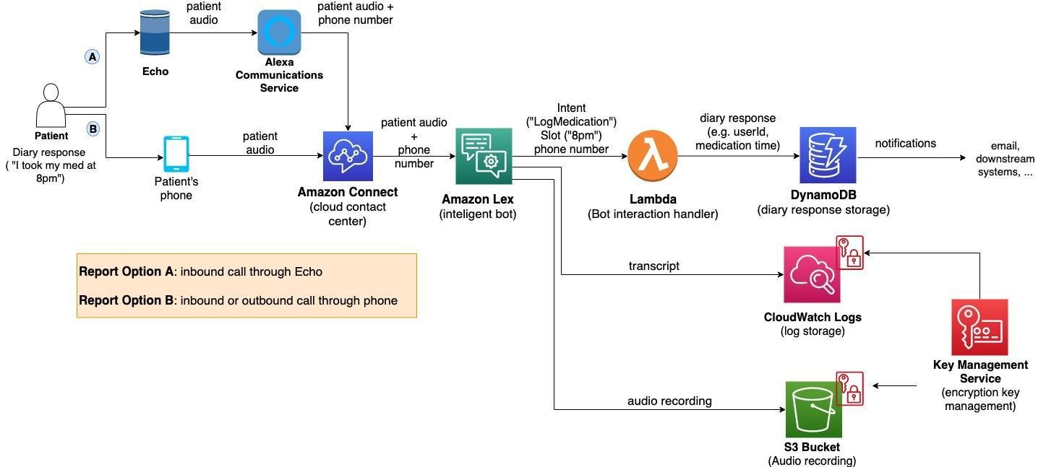
Figure 1: Architecture and data flow of the voice patient diary sample application
Reference: https://aws.amazon.com/blogs/industries/voice-applications-in-clinical-research-powered-by-ai-on-aws-part-1-architecture-and-design-considerations/

Implemented Architecture
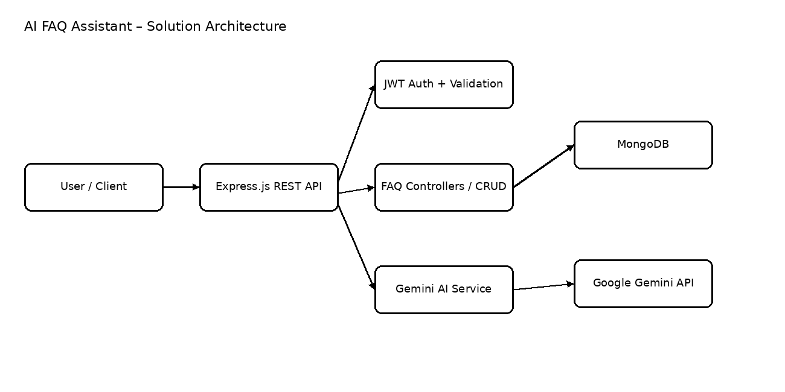
Architecture Components
Component | Responsibility
Client / API Consumer | Sends HTTP requests and receives JSON responses.
Express.js Application | Routes requests, parses JSON, enables CORS and coordinates controllers.
Authentication & Validation | JWT verification, request validation, password hashing and authorization checks.
FAQ Controllers | Create, read, update, delete and search FAQ records.
Gemini Service | Calls Google Gemini models for direct answers and structured FAQ generation.
MongoDB / Mongoose | Persists users and FAQ records and provides schema validation.
Error Middleware | Centralizes HTTP error responses and handles duplicate, validation and cast errors.

